**Objective 1:**

**Objective 2:**

**Algorithm -**

1. **Associate Floating IP to the VM to be monitored.**
2. **Go to the jump host via netmiko and then ssh further into Virtual Machine.**
3. **Run top command and extract the CPU idle percentage.**
4. **Extract the details like flavor, image and network details from the VM to be monitored.**
5. **Use novaClient Python API to spin new instances with similar configurations.**

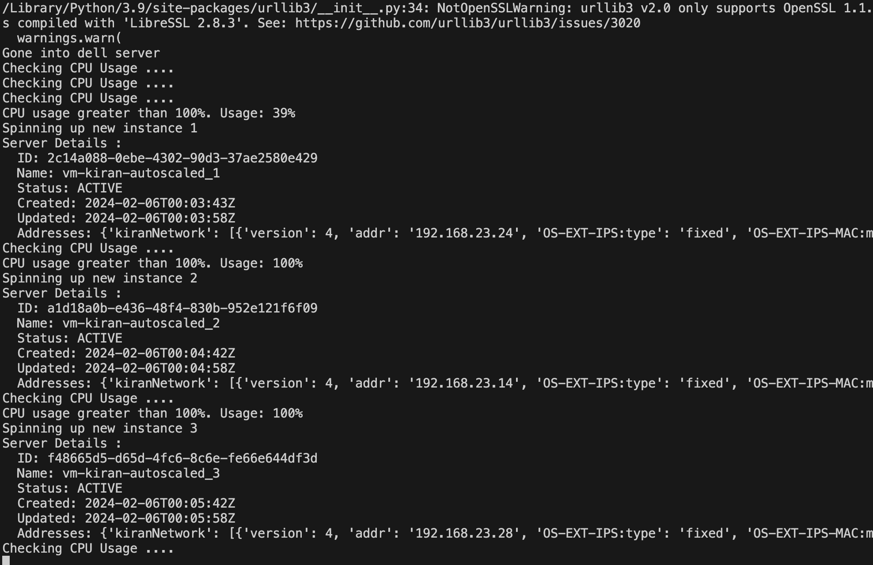

**Objective 3:**

**Objective 4:**